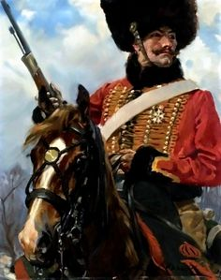
Rough Riders codex ideas.
General rule changes:
Cavalry Warlord Traits:
The captain of a mounted company represents an individual with years of experience in the skills of mounted combat: Speed, ferocity, cunning. To represent this, a warlord of a mounted company may roll on the following Warlord traits table to represent his unique skills.

- Glory seeker: This warlord seeks personal combat to prove her prowess. She is an expert in duels of all nature. When fighting a challenge the warlord has the Eternal Warrior skill and receives +1 A and +1 I.
- Raging Bull: The thundering charge of cavalry lives in your warlord’s soul. The warlord and his unit gain the Rage ability.
- Expert Rider: Your warlord and his command squad were born in the saddle. They ride better than they walk, and can control their mounts with superhuman skill. Your warlord and his unit gain a 5+ invulnerable save against all shooting attacks, and may re-roll failed wounds on Hammer of Wrath attacks.
- Master of Mobile Warfare: Your warlord is a perfect judge of his mounted units reach and speed. He always seems to have his units positioned perfectly for that precision assault. The warlord may nominate d3 units at the beginning of the game, after set-up, to make a scout move.
- Expert Tactician: Your warlord is an expert at baiting his enemies into fighting on ground and at the time of her choosing. When rolling for Seize the Initiative, you seize the initiative on a 4+ on the die roll. If you already have the first turn, your opponent loses any chance to Seize the Initiative.
- Master of command: Your warlord has proven himself in dozens of battles and his men would follow him anywhere, safe in the knowledge that his orders are always correct. The warlord may issue one extra command per turn.

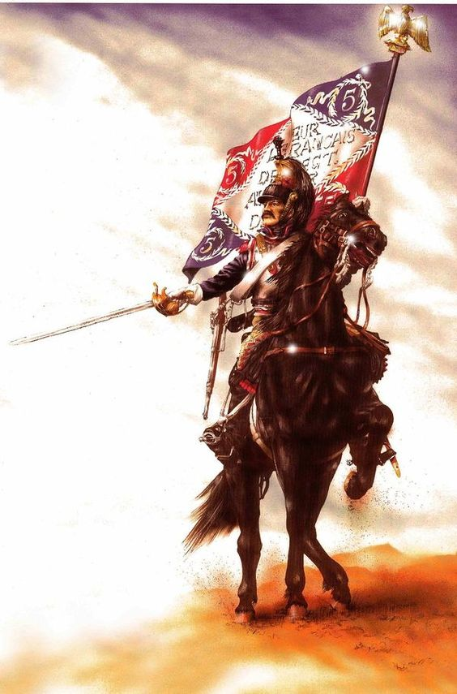
Standards:
Mounted companies place great stock in the illustrious banners they bear, as many can trace their heritage back to the ancient knights of yore. Whether sewn by the very hands of a sainted priestess or stained with the blood of a dozen brave men from ages past, each is a unique creation and consecrated by the deeds it has witnessed and the men who have carried it aloft. A unit carrying one of the following banners gains the listed bonus.
- Company Standard: The company standard holds such reverence for the members of the company that they would do anything to keep it from falling into enemy hands. While bearing a company standard, the command unit gains +1 WS. Furthermore, a company command squad that fails a check for morale in CC and flees, may choose to remove a model and then re-roll their sweeping advance (this can only be used once per sweeping advance). This represents a veteran sacrificing themselves to keep the banner from enemy hands.
- Platoon Standard: Platoons carry great pride in their banners, which are often hand made by its members. A platoon standard allows the unit to re-roll any test to rally when fleeing.

Heirlooms of Conquest
Mounted companies have served humanity since before space travel, with whispered rumors claiming they ruled the world back when man was primitive and lacked the light of the emperor. In any case, every company carries the trophies and artifacts of its forebears. The following list offers a selection of special wargear seen in the hands of mounted companies.
- The Holy Lance of Camelot: (Cost 30) This is a power weapon that has the following profile. The first set of numbers apply to when the character charges, the second to any subsequent round of combat.
S: +3/1 AP: 2/3 Type: Melee, specialist
- The Shield of Galahad: (Cost 15) This is a shield worn on the left hand. A model with the Shield of Galahad can never take the bonus for a weapon in each hand. The Shield of Galahad confers a 3+ Invulnerable save against melee attacks only.
- The Unicorn Plume: (Cost 25 points) Rumored to carry the mane hairs of a unicorn as its streamer, this helm has mystical power inherited from its namesake. The bearer becomes a level 1 psycher, but must take powers from the Divination list.
- The Ancient Tome of Falconry: (Cost 15)Your warlord has studied the ancient art of falconry, and has a loyal companion linked cybernetically to his mind. This bird allows you to see the battle field from above. This allows you to pick out targets at will despite terrain. Once per turn, the warlord and his unit can draw line of sight to any unit in range regardless of terrain. Furthermore, that unit loses any cover save against the warlord and his unit’s shots.
- The Fox’s Doom: (Cost 15) This is an ancient shotgun built with plasma technology now lost to the universe. It has the following profile: Range: 12” S: 4 AP: 2 Assault 2, Gets Hot
- The Wind Banner: (Cost 25) This platoon standard is rumored to be made from the very storm clouds themselves. Once per game, when declaring a charge, the unit bearing the Wind Banner may unfurl it. Their steeds seem to leap across the distance as if born by the wind itself. The unit they charge loses its opportunity for Overwatch fire. (Any platoon may purchase this upgrade, but only one may be purchased)
- Heavy Plate Armor: (15) This is one of the ancient suits worn by the knights of old, now made even more invulnerable by the addition of composite ceramite plates. Thick armor covers the wearer and protects him as no other armor in history has. The wearer has a 3+ armor save.

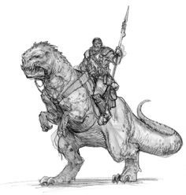
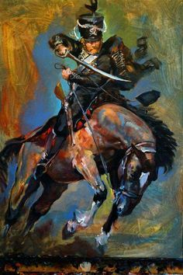
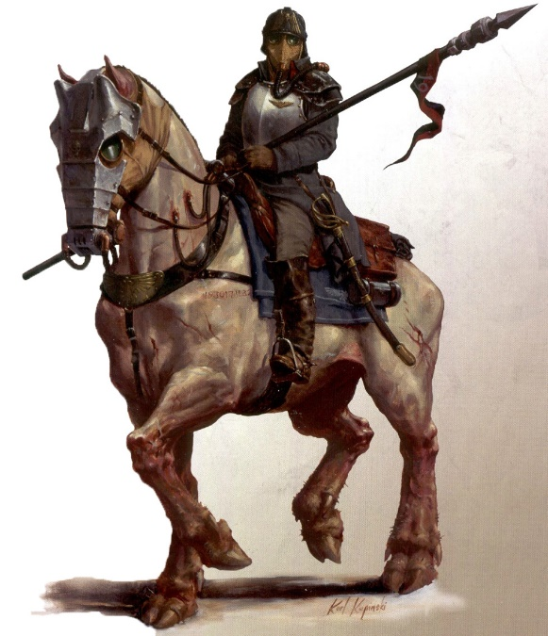

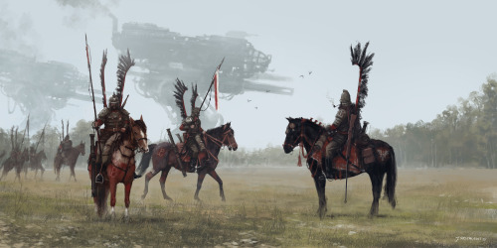
HQ options
Command:
Each company is led by a command section. It is made up of an officer trained and experienced in the art of mounted warfare as well as combat. Around him are gathered the best warriors of the company to act as both bodyguard and example. Whether defending their officer from a sudden assault or leading the charge, the company command squad is always found at the center of the battle. Many a foe has seen the small squad as an easy target, only to fall before the skill and ferocity of veterans who know not how to fail. Even the mightiest foe must be wary, for hidden within the bodyguard of the captain lies the companies champion. A man who knows nothing but battle and whose soul is prepared to meet any threat.

Company Command Squad (80 points for Captain and 4 veterans)
 | WS | BS | S | T | W | I | A | LD | SV | Unit Type
Captain | 4 | 4 | 3 | 3 | 3 | 3 | 3 | 9 | 5+ | Cavalry character
Veteran | 4 | 3 | 3 | 3 | 1 | 3 | 1 | 7 | 5+ | Cavalry
Champion | 5 | 3 | 4 | 3 | 2 | 4 | 2 | 9 | 5+ | Cavalry

Captain

Wargear
Flak Armor
Laspistol
CC weapon
Frag grenades
Refractor field
Special Rules:
Senior Officer
Voice of Command

Options
May take items from the melee weapons, ranged weapons, special weapons and Heirlooms of conquest list.
May purchase a hunting lance for +5 points.

Veterans

Wargear
Flak Armor
Hunting Lance
Laspistol
CC weapon
Frag Grenades

Options
Any veteran may replace their Hunting Lance with a shotgun or a lasgun for free
One veteran may carry a Company standard for +15 pts
One veteran may carry a medi-pak for +15 pts
One veteran may buy an item from the special weapons’ list
All veterans may take any of the following;
Carapace armor (2pts)
Krak Grenades (1 point)

Company Champion:

Wargear:
Mount
Hunting Lance
Las pistol
CC weapon
Carapace armor
Frag grenades
Special Rules:
Rage
Counter-attack
Heroic Intervention Eternal Warrior

Cost/Options:
One rough rider from the company command squad may be upgraded to be the company champion for +25 points. They may purchase a power weapon for +15 points, which is Master Crafted.,

Advisors for a mounted company:
Advisors are purchased as independent characters. Each must be assigned to a unit at the beginning of the battle, and two cannot be assigned to the same unit. Only one of each advisor may be purchased. The cost of an advisor includes his mount.

Advisors for a Mounted Company
 | WS | BS | S | T | W | I | A | LD | SV | Unit Type |  | cost
Master of the Baggage Train | 4 | 3 | 3 | 3 | 1 | 3 | 2 | 8 | 5+ | Cavalry, character |  | 25
Master of the Armory | 4 | 3 | 3 | 3 | 1 | 3 | 2 | 8 | 5+ | Cavalry, character |  | 25
Master of Mounts | 4 | 3 | 3 | 3 | 1 | 3 | 2 | 8 | 5+ | Cavalry, character |  | 30
Master of the Spirit | 3 | 3 | 3 | 3 | 2 | 3 | 1 | 8 | 5+ | Cavalry, character |  | 30

All Models:

Wargear:
Flak Armor
Laspistol
CC Weapon
Options
Any advisor may trade their Laspistol for an item from the Ranged Weapons list
The Master of the Armory may Purchase Carapace armor
Any model may purchase a hunting lance for +5 points

- Master of the Baggage Train: (25 points) This is an expert in the chain of supply. An army that includes a Master of the Baggage Train rarely has issues with ammo supply, horseshoes, saddles, etc. Each turn the Master of Baggage can make a Leadership test. If successful they may enact one of the following powers;
  - Ammo re-supply: The unit may choose to re-roll their rolls to hit in their shooting phase.
  - Well-fed mounts: The unit may roll 3 dice and take the highest two for its charge distance.
- Master of the Armory: (25 points) This represents one of the expert blacksmiths and armorers who maintain the regiments equipment. A Master of the Armory can make a leadership roll at the beginning of each turn. If successful, he can enact one of the following powers;
  - Honed blades: The Master of the Armory has taken the time to hone the unit’s blades to a razor’s edge. They may re-roll failed to wound rolls in the assault phase this turn.
  - Buckles and plates: The Master of the Armory has gone over the unit’s armor with a fine-toothed comb and put it in perfect condition. They may re-roll failed armor saves during the assault phase of this turn.
- Master of Mounts: (30 points) This represents an expert in the care and training of mounts. The Master of Mounts adds the Feel no Pain (5+) ability to the unit he joins.
- Master of the Spirit: (30 points) The Master of the Spirit sees to the regiments faith and spiritual needs. He is a chaplain, shaman, witchdoctor, psychologist, whatever fits. He is a level 1 Psycher who must choose his power from the Divination List. The Master of Spirit can be made a level 2 psycher for +25 points.
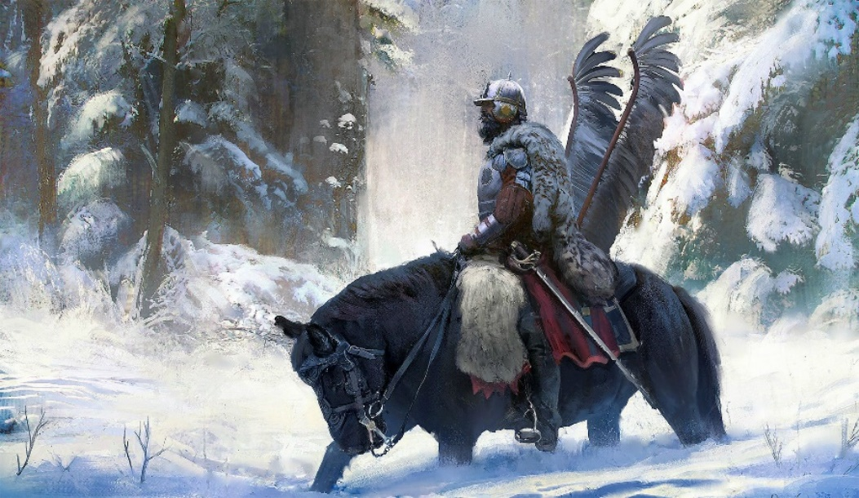
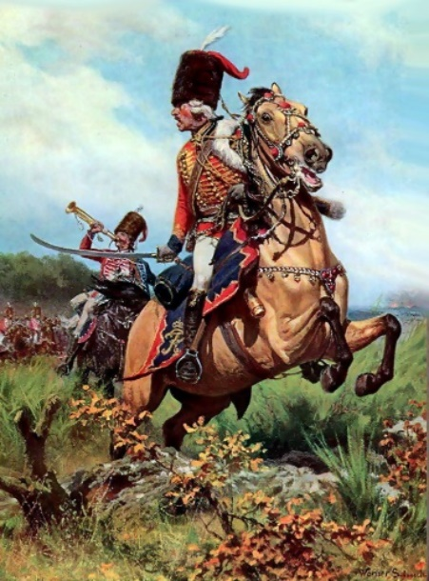

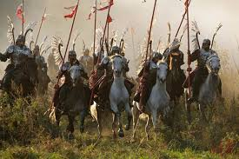
Elite unit choices:

Hussars
Hussars represent the best and most dedicated horsemen in the unit. Hussars always lead the parading of the unit, and the splendor and perfection of their uniforms is only matched by the precision of their drill. These are no barracks warriors however. No man is allowed into the Hussars until he has proven his worth in combat among his fellows. Only a vote by the company’s officers and veterans raises a man to the prestige of Hussar. With this honor comes sacrifice. When the assault is called for, when a breach opens in the lines, when backs are against the wall, when the enemy’s strongest appears, it is always to the Hussars a Captain looks to deliver the blow that crushes resistance or staves off doom.

Hussars (Only one unit of Hussars may be purchased) Cost: 75pts for 4 Hussars and a Veteran Sergeant
 | WS | BS | S | T | W | I | A | LD | SV | Unit Type
Hussar Veteran Sergeant | 4 | 3 | 3 | 3 | 1 | 3 | 2 | 8 | 5+ | Cavalry Character
Hussar | 4 | 3 | 3 | 3 | 1 | 3 | 1 | 7 | 5+ | Cavalry

Wargear
Flak Armor
Hunting Lance
Laspistol
CC Weapon
Frag Grenades
Platoon Standard
Special rules
Stubborn
Crusader
Counter-attack
Jink (6+)

Options
Up to 5 more Hussars may be purchased at 15 points each.
The unit may purchase any of the following;
Carapace armor (2 pts per model)
Krak grenades (1 pt a model)
The Sergeant exchange his Laspistol for a plasma pistol for 15 points and/or his hunting lance for a power sword for 15 points

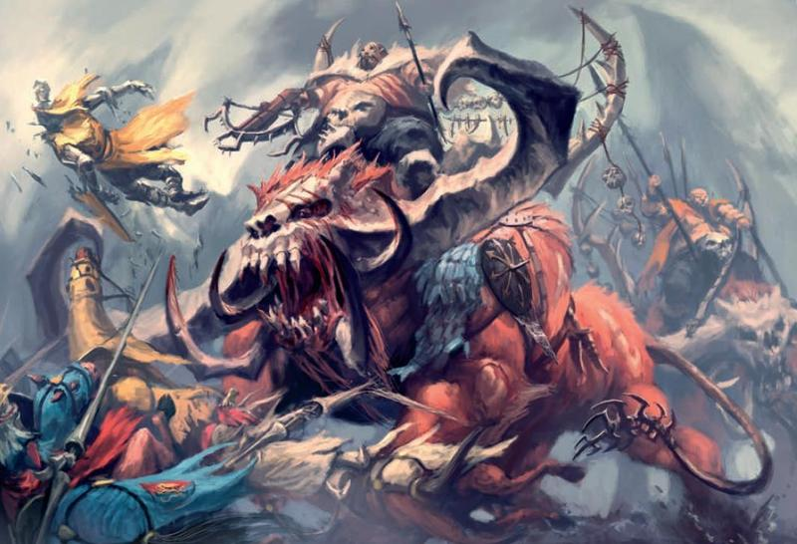
Ogrynn Riders
Some Mounted Companies look for a greater punch. All across the galaxy, on a thousand planets, primitive cultures have returned to their ancient roots, where strength of arms decides all. Often, primitive, high gravity worlds are dominated by huge beasts who can only be tamed by the massive strength of an Ogrynn. Mounted companies with their high attrition rates and dangerous assignments are often glad to accept such striking power into their ranks. Though rare, the charge of an Ogrynn squad is devastating, and the quaking of the ground and bellowing of deep voices is the last thing many an enemy has heard.

Ogrynn Mounted Squad: Cost 175 for 2 Ogrynn troopers and a Bone’ead
 | WS | BS | S | T | W | I | A | LD | SV | Unit Type
Ogrynn Trooper | 4 | 3 | 5 | 5 | 3 | 2 | 3 | 6 | 5+ | Calvary Character
Bone’ead | 4 | 3 | 5 | 5 | 3 | 2 | 4 | 7 | 5+ | Calvary

Wargear
Flak Armor
Ripper Gun
Hunting lance

Special Rules
Hammer of Wrath; Because of their bulk as well as their mounts, Ogrynns may re-roll failed wound rolls caused by Hammer of Wrath hits
Stubborn
Very Bulky

Troop choices
Mounted infantry Platoons
The heart of any mounted company is the mounted platoon of troopers. Trained in the art of mounted warfare, they range the gamut from hardened veteran to novice. Flexible in their armament and role, platoons of troopers can fill almost any need on the battlefield.

Rough Rider Trooper Platoon: Cost 45 for 4 troopers and a veteran sergeant
 | WS | BS | S | T | W | I | A | LD | SV | Unit Type
Veteran sergeant | 3 | 3 | 3 | 3 | 1 | 3 | 2 | 8 | 5+ | Calvary character
Trooper | 3 | 3 | 3 | 3 | 1 | 3 | 1 | 7 | 5+ | Calvary

Wargear
Flak Armor
Lasgun
Frag grenades
Laspistol (SGT)
CC weapon (SGT)
Options
Up to 5 more troopers may be purchased for 9 points each
The sergeant may exchange his laspistol OR CC weapon for an item from the ranged weapons list
Up to two troopers may exchange their lasgun for items from the special weapons list
The platoon may take a platoon standard for +5 points

Raw recruits
Because of the highly mobile and specialized nature of a mounted company, the task of training replacements is undertaken by each company on the move. Raw recruits are given basic training on the job from the veterans around them. Often, they are given a baptism of fire in limited roles on the battlefield.

Raw recruits: Cost 70 points for 9 raw recruits and one training trooper
 | WS | BS | S | T | W | I | A | LD | SV | Unit Type
Recruit | 2 | 2 | 3 | 3 | 1 | 3 | 1 | 5 | 5+ | Cavalry
Training trooper | 3 | 3 | 3 | 3 | 1 | 3 | 1 | 7 | 5+ | Calvary

Wargear
Flak Armor
Lasgun
Options
Up to 10 more recruits may be purchased at a cost of 7 points each

Horse scouts
Mounted companies often head off on deep penetration raids where they disrupt enemy communications, supply trains, and rear echelon staging areas. Scouts protect the flanks, find paths, and prevent the enemy from locating the main body. Independent, self-sufficient, loners, scouts work in small units and rarely mingle with the main body of troopers.

Scout troopers: Cost 30 points for 2 Scout troopers and a scout sergeant trooper
 | WS | BS | S | T | W | I | A | LD | SV | Unit Type
Scout Sergeant | 3 | 4 | 3 | 3 | 1 | 3 | 2 | 8 | 5+ | Cavalry character
Scout | 3 | 3 | 3 | 3 | 1 | 3 | 1 | 7 | 5+ | Calvary
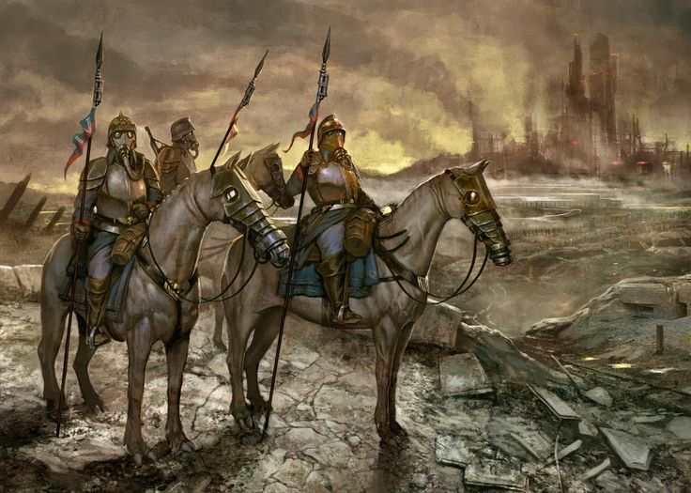

Wargear
Flak armor
Lasgun
Laspistol
CC weapon
Frag Grenades

Special Rules
Scout
Hit and Run
Shoot sharp and scarper

Options
Up to 2 more scouts may be purchased for 10 pts each
The unit may purchase Camo cloaks for 1 pt per model
Any model may exchange their lasgun for a shotgun for free
Any model may purchase a Sniper Rifle for 2 pts
The sergeant may purchase melta bombs for +5 points

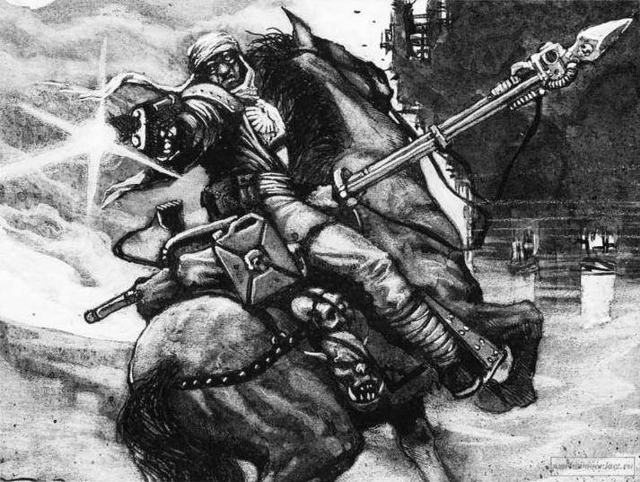
Fast Attack Choices

Lancer Platoons
The main striking power of a mounted company will always lie at the point of its lances. Trained as expert riders, their courage undoubted, platoons of mounted lancers thunder through any barrage the enemy can put up and smash home with incredible fury. Few foes have the courage to stand and deliver aimed shots once the thunder of hooves reaches them, and dozens of worlds owe their existence to the iron resolve of mounted lancers who carried their charge to its glorious end despite enormous casualties.

Lancer Platoon: Cost 55 for 4 lancers and a lancer Sergeant
 | WS | BS | S | T | W | I | A | LD | SV | Unit Type
Lancer Sergeant | 3 | 3 | 3 | 3 | 1 | 3 | 1 | 8 | 5+ | Cavalry Character
Lancer | 3 | 3 | 3 | 3 | 1 | 3 | 1 | 7 | 5+ | Cavalry

Wargear
Flak Armor
Laspistol
CC weapon
Hunting Lance
Frag Grenade
Krak grenade
Options
Up to 5 more Lancers may be purchased at a cost of 11 pts each
The sergeant may replace his laspistol and/or CC weapon with a Plasma Pistol (+15) or a power weapon (+15)
The sergeant may take Melta bombs (+5 pts)
Up to two lancers may be armed with a flamer (+5 pts) or Grenade launcher (+5 pts)
The platoon may take a platoon standard for +5 points

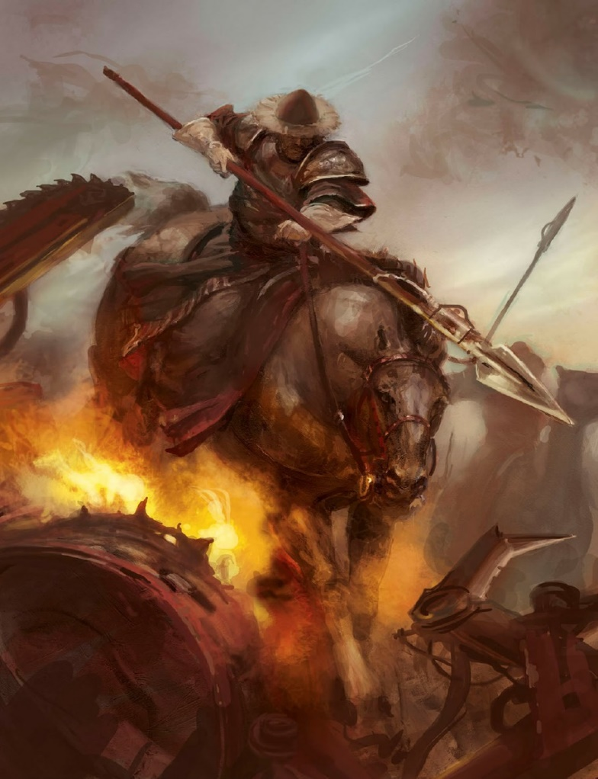
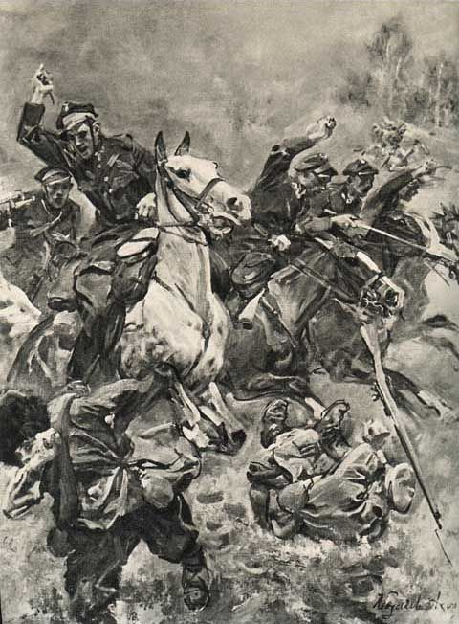
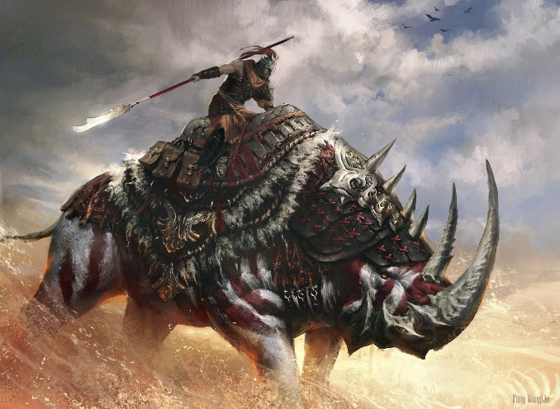
Heavy Choices

Heavy Cavalry
Most mounted companies outfit at least one platoon as super heavy cavalry. This goes farther than simply wearing heavier armor, but includes the largest mounts available. Giant lizards, great bears, wooly rhinoceros, eight-legged sparktusks from Nordar IV, any and all such beasts have been seen in heavy platoons. Only volunteers are accepted, for these units take on the most dangerous charges. Ranks of armored vehicles? Bunkered autocannons? A phalanx of carnifex’s? All are targets for the lances of the company’s heavy platoon.

Heavy Platoon: Cost 75 points for 4 heavy lancers and a Heavy lancer sergeant
 | WS | BS | S | T | W | I | A | LD | SV | Unit Type
Sergeant | 3 | 3 | 3 | 4 | 1 | 3 | 2 | 8 | 4+ | Cavalry character
Heavy lancer | 3 | 3 | 3 | 4 | 1 | 3 | 1 | 7 | 4+ | Cavalry

Wargear
Carapace armor
Laspistol
CC weapon
Hunting Lance
Frag grenades
Special Rules
Heavy mounts lose
fleet but gain +1 S
for Hammer of
Wrath wounds
Options
Up to 5 more heavy lancers may be purchased for 15 points each
The heavy sergeant may exchange his CC weapon for a Power fist for +25 points

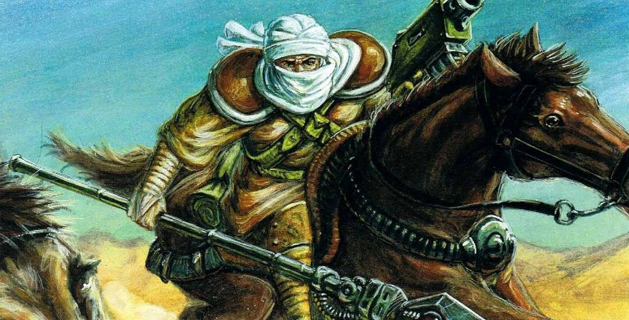
Tank-hunters
Enemies often defend their supply trains or rear facilities with armor and worse when they know a Mounted company is operating behind the lines. To counter this, a select few are trained in the fine art of tank-hunting. Shunned by the rest of the company for the explosives they display openly and often treat in a haphazard way, these men are oddballs among a unit of eccentrics. Yet, every mounted trooper knows when the cry of “Armor!” rings out, their lives lie in the hands of the tank-hunters and their various can-openers.

Tank-Hunters: Cost 39 for 2 tank-hunters and a tank-hunter sergeants
 | WS | BS | S | T | W | I | A | LD | SV | Unit Type
Sergeant | 3 | 3 | 3 | 3 | 1 | 3 | 2 | 8 | 5+ | Cavalry character
Tank-hunter | 3 | 3 | 3 | 3 | 1 | 3 | 1 | 7 | 5+ | Cavalry

Wargear
Flak armor
Laspistol
CC weapon
Shaped charge Hunting lance
Options
Up to two more Tank-hunters may be chosen at 13 points each
The sergeant may purchase melta bombs (+5 points)
The sergeant may carry a demolition charge (+20 points)
Up to two tank-hunters may purchase items from the special weapons list

A shaped Charge hunting lance has the armorbane rule

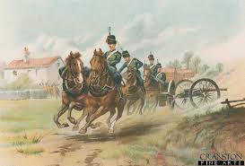
Horse Artillery
Even deep raid companies need some firepower. Whether blasting a strongpoint’s gate or stopping an armored strike force from ambush, the role must be filled. Many mounted companies have field artillery pulled by teams of mounts. These light weapons can be pulled into position quickly, fire off a volley, and towed to a new position before retaliation. Crewed by experts, led by artillery experts, they are often the difference between success and failure.

Horse artillery: 18 points for a single gun carriage
 | WS | BS | S | T | W | I | A | LD | SV | Unit Type
Gun carriage | 3 | 3 | 3 | 3 | 2 | 3 | 1 | 7 | 5+ | Cavalry
Master of Arms | 3 | 4 | 3 | 3 | 1 | 3 | 1 | 8 | 5+ | Cavalry character

Wargear
Flak armor
Lasgun (gunners)
Laspistol (master of arms)
CC weapon (Master of arms)
Special Rules
Heavy Weapons team
Very Bulky
Shoot sharp and scarper
Gun Shield
Split fire (master of arms only)
Options
Up to two more gun carriages may be added at 20 points each
Each gun carriage must purchase a weapon from the heavy weapons list at the price listed
May purchase a Master of arms for the unit at +10 points
The Master of arms may exchange his CC weapon for a power weapon for +15 points

Shoot sharp and scarper: The unit may make a run move after it has fired in the shooting phase.
Gun Shield: From the front, the unit has a Gun Shield protecting the weapon and crew. Any shots from the front arc, the gun crew’s save is increased to 3+.
